

***The National Flag of Free Vietnam***

*(Recognizing only the Yellow Flag with Three Red Stripes*   
*for and by the exiled Vietnamese around the world - Biet Hai)*   
 

[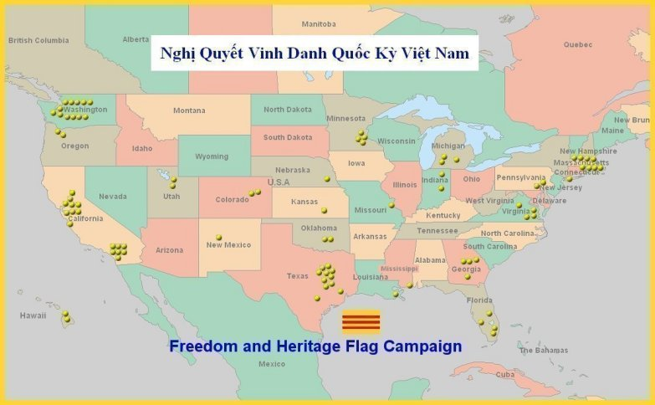](http://quockyvietnam1.tripod.com/freedom_flag_main_map.jpg)

|  |  |
| --- | --- |
| **QUỐC-CA VIỆT-NAM CỘNG-HÒA**  Này công-dân ơi! Đứng lên đáp lời sông-núi!  Đồng lòng cùng đi, hy-sinh tiếc gì thân sống.  Vì tương-lai quốc-dân, cùng xông-pha khói tên,   Làm sao cho núi sông từ nay luôn vững bền.  Dù cho thây phơi trên gươm-giáo,  Thù nước lấy máu đào đem báo!  Nòi-giống lúc biến phải cần giải nguy,   Người công-dân luôn vững-bền tâm-trí,  Hùng-tráng quyết chiến-đấu làm cho khắp nơi,   Vang tiếng người Nước-Nam cho đến muôn đời.  Công-dân ơi! Mau hiến-thân dưới cờ!  Công-dân ơi! Mau làm cho cõi-bờ,   Thoát cơn tàn-phá, vẻ-vang nòi-giống,  Xứng danh nghìn năm dòng-giống Lạc-Hồng.*  -----------------------  Ghi-Chú:   * “Lạc-Hồng” hay “Hồng-Lạc”: các vị vua đầu-tiên  của dân Việt, Vua Hồng-Bàng (King-Dương-Vương)  và Lạc-Long-Quân. Trong triều-đại đầu-tiên của   dân Việt (2879 - 258 trước tây-lịch), Kinh Dương  Vương (Hồng-Bàng) là vị vua đầu-tiên của nước ta,   Lạc-Long-Quân là vị vua thứ nhì của nước ta. | **The National Anthem of the Republic of Vietnam\***  Oh citizens! Stand up to respond to the fatherland’s request!   With the same heart we go, sacrifice ourselves, don’t regret our lives.   For our people’s future, together we enter the warfare with courage!  Try to secure our fatherland to be always durable from now on!  Even if our corpses display on weapons,  For national revenge, we should take our rosy blood to avenge!  When our race has calamity, we must deliver our people from danger!  Citizens should always be stable in mind!  Determine mightily to struggle everywhere,   To make Vietnamese reputation resound forever !  Oh citizens! Hurry up to offer your lives under the national flag!  Oh citizens! Hurry up to help our fatherland  Escape from destruction, make our race glorious,   To be eternally worthy of the Lac-Hong** race!  -----------------------  Notes:   * This English Translation was translated by Khai-Chinh Pham Kim-Thu  **“Lac-Hong” or “Hong-Lac”: the ancestors of the Vietnamese race, Hong-Bang (Kinh-Duong-Vuong)  and Lac-Long-Quan. In the first dynasty in Vietnamese history (2879 - 258 B.C.), Hong-Bang (King Duong Vuong) is the First King of Vietnam, and Lac-Long-Quan is the Second King of Vietnam. |

**The National Flag of Free Vietnam**

**By Khai Chinh Pham Kim Thu**

  **The National Flag of Free Vietnam has yellow background and three horizontal red bands in the middle of the flag.**

***I. The Meaning of National Flag of Free Vietnam's Colors:***

         The yellow background represents the ancestral land and the skin color of Vietnamese race. The yellow color also represents earth (one of five elements - metal, wood, water, fire, and earth) symbolizing the territory and the national sovereignty. That is why the oriental emperors in the past wore Hoang Bao (yellow emperial robe) and proclaimed themselves Hoang De (Yellow Emperors).

         The red color represents fire (one of five elements mentioned above). The red color is also the color of the South and symbolizes a brave, un-submissive, heroic, and independent race in the south region, Vietnam, which is separated completely from the north region, China.

         The three red bands represent the three regions of Vietnam: North, Central, and South. But, these three regions unite in the national home, the home of Vietnamese people, who always love and protect one another.   
    
  ***II. Origin, Formation, Philosophic Symbol of National Flag of Free Vietnam:***

         In 40 AD, the Truong Sisters, on the elephants' back, waved the Yellow Flag to fight against the Chinese invaders to regain independence for Vietnam. Since that year, the Yellow Flag appeared for the first time in the Vietnamese history.

         In the Gia Long dynasty (1802-1820), the Yellow Flag was also used as the symbol of the Vietnamese Nation. In the Khai Dinh dynasty (1916-1925), the two red bands were added to the Yellow Flag to form the Long Tinh flag (Dragon Flag).

         In 1945, when Tran Trong Kim's government came into power, the middle broken red band was added to the flag in the position between the two red bands of the former Yellow Flag to form the *Que? Ly Flag*. The *Quẻ Ly Flag* was the official flag of Vietnam at that time. *Quẻ Ly* is a divination sign of fabulous unicorn, sixth of the Bát Quái (the Eight Trigrams): *Càn, Khảm, Cấn, Chấn, Tốn, Ly, Khôn, Đoài.* This divination sign of fabulous unicorn represents the sun, fire, beam of light, and civilization.

         In 1948, when the former Emperor Bao Dai became the Chief of State of Vietnam, he ordered to change the broken red band into a continuous red band to form the Yellow Flag with three yellow red bands. Then, on June 2nd, 1948, the Chief of the Temporary National Government of Vietnam, Brigadier General Nguyen Van Xuan, signed the Ordinance to specify the characteristics of the Free Vietnam National Flag as follows: The national emblem is a flag of yellow background, the height of which is equal to two-thirds of its width. In the middle of the flag and along its entire width, there are three horizontal red bands. Each band has a height equal to one-fifteenth of the width. These three red bands are separated from one another by a space of the band's height.

         The three red bands have the divination sign of *Quẻ Càn*, the first of the Eight Trigrams mentioned above. Quẻ Càn represents heaven. Based on the world view of Vietnamese people, *Quẻ Càn* indicates the South Sky, the Vietnamese Nation, Vietnamese people, and the people's power.   
    
  ***III. The Sacred Symbol and Special Meaning of The National Flag of Free Vietnam:***

         The National Flag of Free Vietnam has been formed from the sacred energy of sky and earth of Vietnam together with indomitable spirit of Vietnamese people during almost two thousand years of history since this flag was officially adopted by an Ordinance. It represents the peaceful opportunity, the everlasting success, and the imposing victory of Vietnamese people.

         The National Flag of Free Vietnam has been ups and downs with the Vietnamese people's imposing history. It represents democracy, freedom, human rights, brave will, peace and prosperity, and unity during the course of building and protecting the country of Vietnamese's ancestors.

         The National Flag of Free Vietnam is not solely the property of any regime or any government. It is the state property of free Vietnamese people. Should a regime be rotten or a government a lackey to foreign powers, the Free Vietnam National Flag does not risk a bad reputation. The Vietnamese people have to eliminate that regime or that government to protect their ancestors' flag colors. We cannot rely on the argument that the previous regimes or governments were no longer existed in order to be indifferent to this flag.

         The National Flag of Free Vietnam is the nation's soul. The righteous cause, the fighting morale, and the unanimous unity depend on the presence of this flag. The Free Vietnam National Flag is a denotation to identify those who are Vietnamese freedom-loving people and those who are Vietnamese Communists and their servants. Where there is a National Flag of Free Vietnamese, there are love, democracy, freedom, and human rights.

         At the present time, there are absolutely no freedom and no democracy of any kinds in Vietnam. Human rights are seriously abused by the Vietnamese communist regime.

         During the course of fighting for freedom, democracy, and human rights of the people in Vietnam, we must have our whole-hearted support to maintain and wave high this National Flag of Free Vietnam until the freedom, democracy, and human rights are finally realized in Vietnam. That is why, each time seeing the Free Vietnam National Flag, the majority of freedom-democracy-loving Vietnamese, in Vietnam as well as around the world, feel as if they saw the nation's savior.

         A great majority of the anti-communist Vietnamese organizations recognize the National Flag of Free Vietnam and consider this flag to be the soul of the unity and the struggle for just cause.

         The National Flag of Free Vietnam continues to be the official emblem of Free Vietnam for the freedom-loving Vietnamese people in Vietnam and abroad.

         We - freedom-democracy-human rights-loving Vietnamese - should always preserve the National Flag of Free Vietnam and together unite under this flag to fight for freedom, democracy, human rights, well-fed and well-clothed condition, happiness, peace, and prosperity of Vietnamese people in Vietnam.

         The year of 1998 was also the year that the people around the world celebrate the 50th Anniversary of the UN Universal Declaration of Human Rights. This is one of the most important documents of this century. The Declaration contains 30 articles that set out fundamental rights that all humanity should be entitled to. The National Flag of Free Vietnam and The UN Universal Declaration of Human Rights were officially adopted in the same year, 1948. This is the significant coincidence of destiny, the perfect harmony for Vietnamese people. This is why the National Flag of Free Vietnam also means human rights for Vietnamese people too.

         With the glorious history of almost 2 thousand years of the National Flag of Free Vietnam, we hope, in the near future, the National Flag of Free Vietnam - yellow background with three red bands - will be fluttering so numerous as to cover the whole Vietnamese sky.